Formal proof general architecture

Purpose
The purpose of this document is to provide a general idea of how the architecture will look like.

Architecture

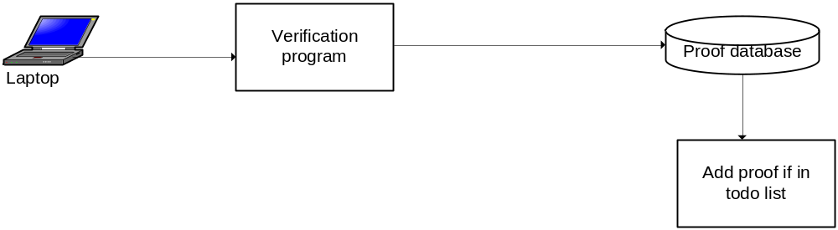

The user sends his proof to the verification program which is a webbased.
The proof will be checked on serverside using whatever is in the proof database.
Once the proof is checked the user will be informed of problems or that the proof was successful. If the proof is something that is in the todo proof list it is added with its proof.
Users may now use this proof as an axiom in other proofs.

Proof structure
A proof consists of the following parts:

Assumptions: given data and propositions.
What to prove: one formula that is to be build out of the assumptions.
Proof

Assumption
This contains the assumptions made involving the proof.
This should contain as little axioms as possible. The used axioms must already be proven.
It is however possible that there are assumptions to be made.

An assumption block consists of statements:
<statement>.
<statement>.
<statement>.

<statement> ::= <function>.
<function> ::= <functionname>( <commaParams>)
<commaParams> ::= <variablename> | <function> | <commaParams>, <commaParams>
An assumption block can also be empty.
Each function is now representable as a tree. A function is transformed from its literal form to a tree structure.
Eg. ‘A or B’ written as prefix this is or(A, B).

or
A
B

What to prove
List of statements of that must be proven.
<statement> => <statement>.
<statement> => <statement>.
<statement> => <statement>.
See ‘Assumption’ for BNF.

Proof

<proof> ::= <axiom> <prooflines>
<prooflines> ::= <proofline> <prooflines> | <proofline>
<proofline> ::= <lineName> <transformrule> <statement>
<axiom> ::= <statements> (statements that are already proven true or can be found in assumptions)
<transformrule> ::= <axiom> <lineName> <transformation>
<lineNames> ::= <string, no spaces>

An axiom is a statement that is proven to be true and can be found in the proven database.
The assumptions in the assumption block must be a superset of the assumptions bound with the axiom assumptions.

A proof starts with an axiom. From there the user will transform the axiom to a new statement. From here the user can create new statements by transforming them.

Transformation
The transformation is very strict and is described as follows:

You quote the axiom the transformation is based upon.
An axiom has the following form:
<assumption statement> => < What to prove statement >

The user provides the system with the substitutions that are made to be equal to the assumptions as well as the lines that should be transformed. After substituting the assumption statements they should be equal to the assumption statements.

Substitution cannot be done without careful consideration.

An example:
Axiom:
1.
Imply(a,b)
To be proven:
Imply(a, b) => Or(a , not(b)).

Proof:
1.

Assumptions that are substring in statements can be replaced by 1 or visa versa.
This is the substrStatement transformation.

A transformation is defined from one formula or more formulae to one new formula.
The transformation can start from a predefined tree and copy a subtree from the before mentioned trees. It can only be applied if all prerequesits is met. These are always involving perfect matches in the formula. Like commutativity of the ‘or function’ can only be applied if the parent of the two subformulas is an ‘or’ node.

Bringing the pieces together

The proof code is gathered and compiled into a tree. This process checks if the form of the formulae is correct.
Now we shall build the deduction tree.

Each node combines formulas and one transformation. The value of the node itself is then the result of the transformation.
All these transformation will lead to a root and only if the root is what is to be proven, the proof is accepted.

